CIS 430: Lab Assignment 5

Name: Yuvaraj Vagula

ID: 2862494

Object: 2 parts; View and Stored Procedure using Cursor

* 1. **View Creation from SQL**

-- Create the view VDept_Budget

CREATE VIEW VDept_Budget AS

SELECT D.DNAME AS Dept_Name, D.DNUMBER AS Dept_Number, COUNT(E.SSN) AS No_Emp

FROM DEPARTMENT D

LEFT JOIN EMPLOYEE E ON D.DNUMBER = E.DNO

GROUP BY D.DNAME, D.DNUMBER;

SELECT * FROM VDept_Budget;

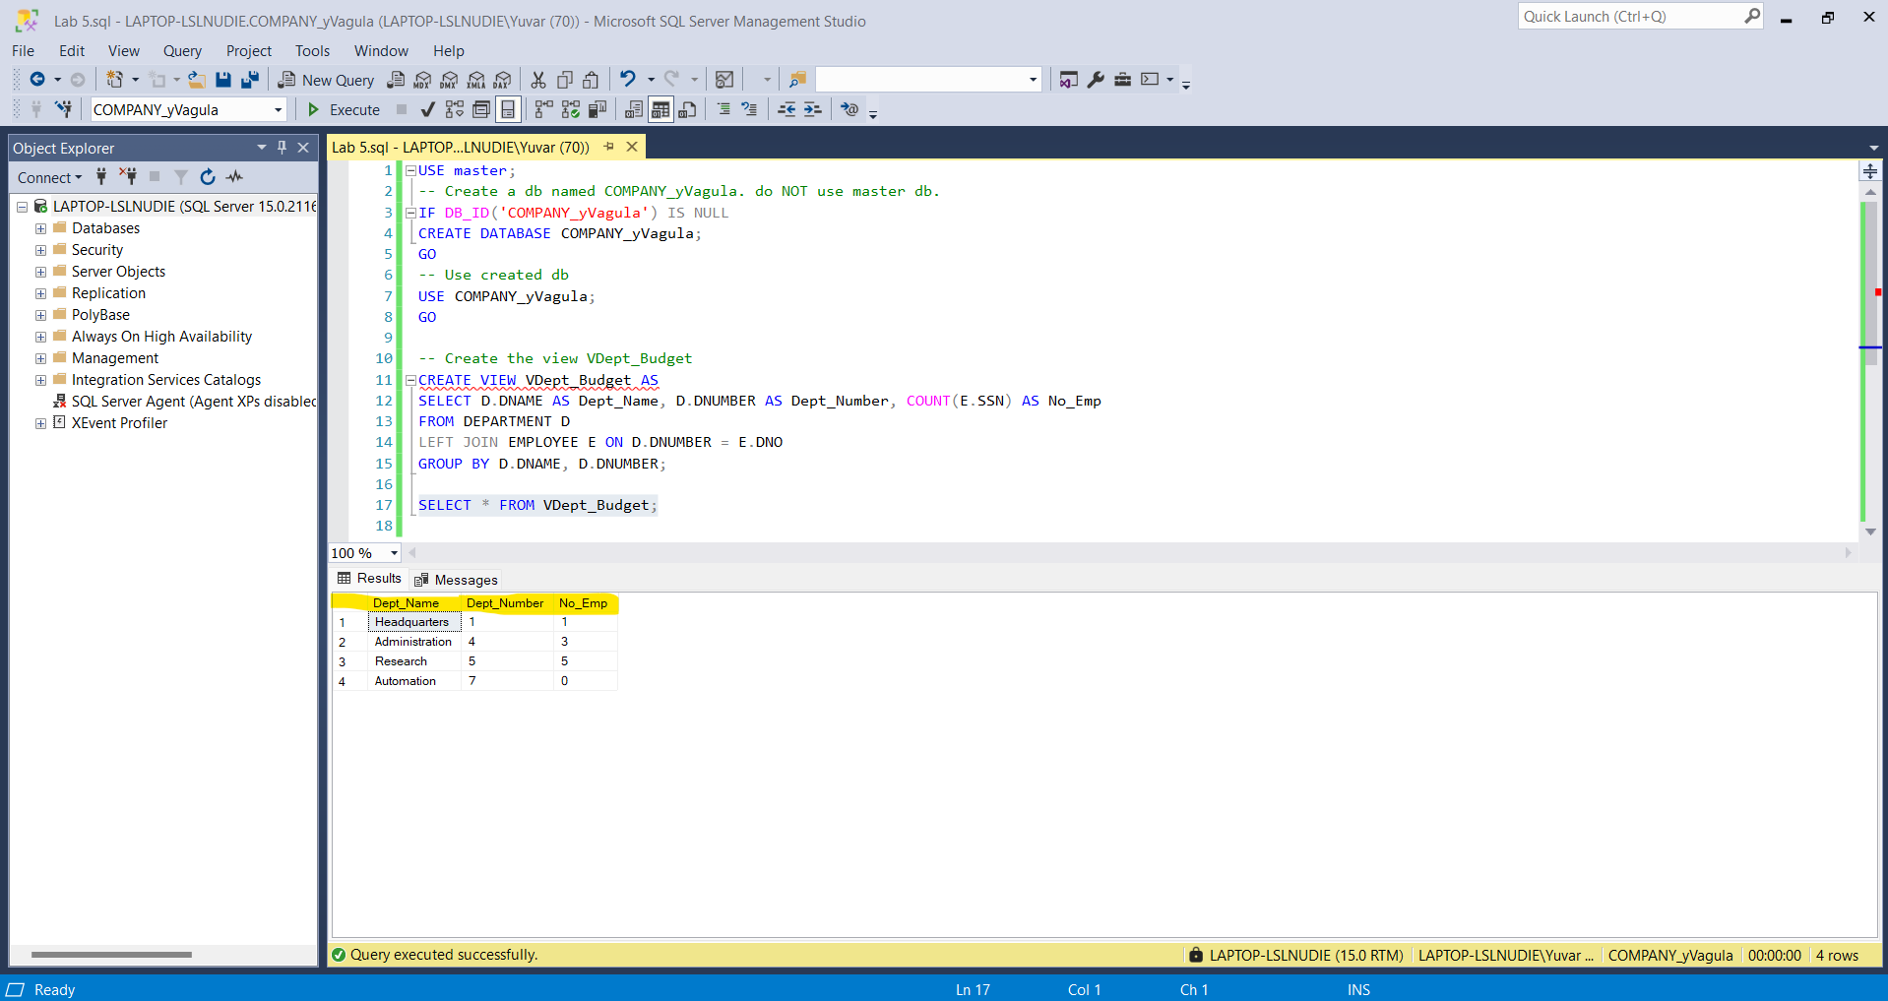

**1-2) Table creation from the same SQL as in 1.1**

CREATE TABLE Dept_Budget (

Dept_Name VARCHAR(15),

Dept_Number INT,

No_Emp INT

);

INSERT INTO Dept_Budget (Dept_Name, Dept_Number, No_Emp)

SELECT D.DNAME AS Dept_Name, D.DNUMBER AS Dept_Number, COUNT(E.SSN) AS No_Emp

FROM DEPARTMENT D

LEFT JOIN EMPLOYEE E ON D.DNUMBER = E.DNO

GROUP BY D.DNAME, D.DNUMBER;

SELECT * FROM Dept_Budget;

**2.**

**2-1 & 2-1) Adding myself and another employee, then showing the View VDEPT_BUDGET content again.**

INSERT INTO EMPLOYEE (FNAME, MINIT, LNAME, SSN, BDATE, ADDRESS, SEX, SALARY, SUPERSSN, DNO)

VALUES ('Yuvaraj', 'N', 'Vagula', '777777777', '2006-05-01', '2121 Euclid Ave, Cleveland, OH', 'M', 50000, NULL, 1),

('John', 'B', 'Doe', '222222222', '1991-02-02', '456 dog St, Shaker, OH', 'F', 50000, NULL, 1);

SELECT * FROM VDept_Budget;

SELECT * FROM Dept_Budget;

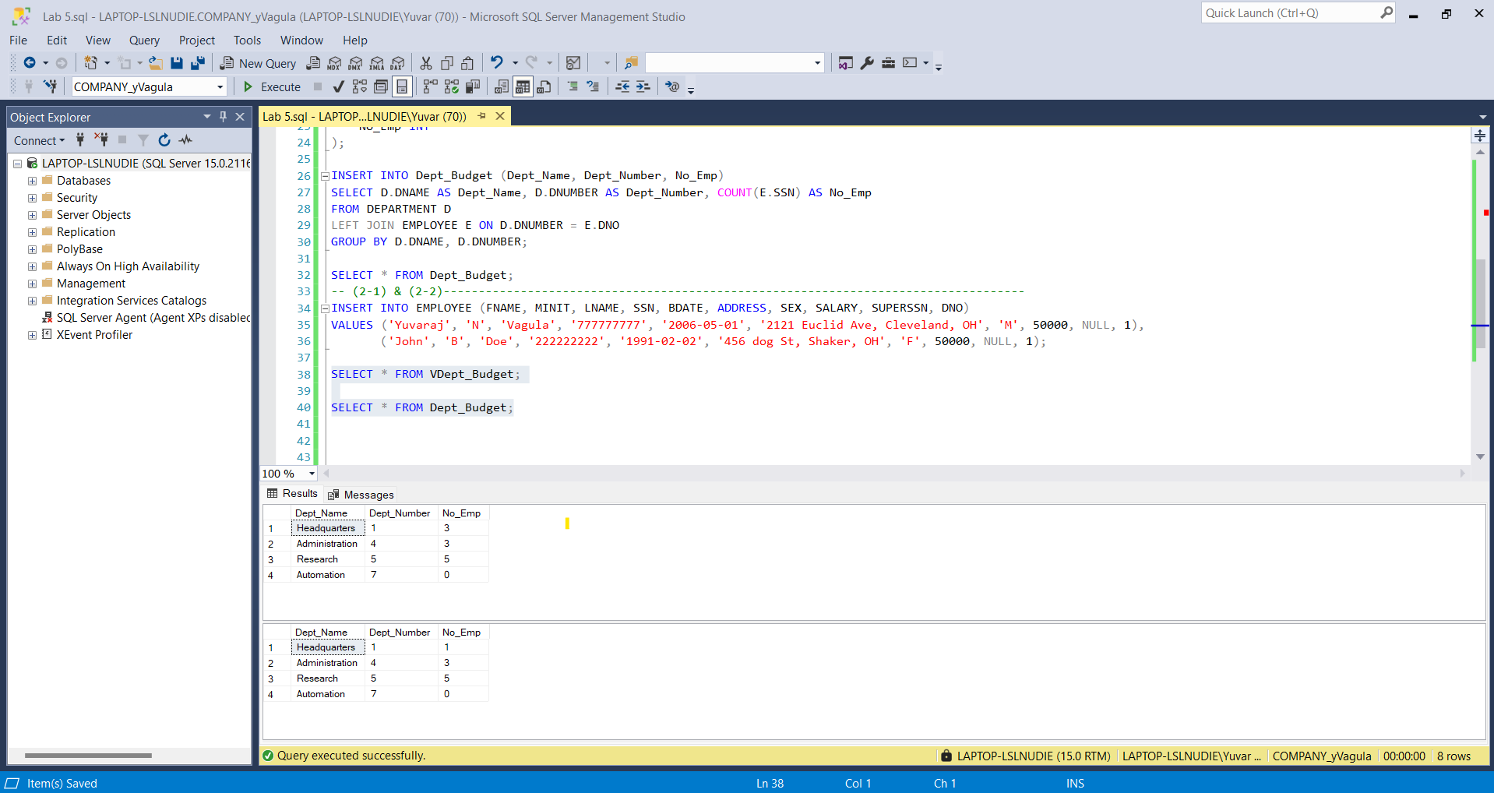

**3) Difference in Changing the Scheme of the Existing View and the Table**

-- Drop the existing view if it exists

IF OBJECT_ID('VDept_Budget', 'V') IS NOT NULL

DROP VIEW VDept_Budget;

GO

-- Create the view with the additional columns

CREATE VIEW VDept_Budget AS

SELECT D.DNAME AS Dept_Name, D.DNUMBER AS Dept_Number, COUNT(E.SSN) AS No_Emp, SUM(E.SALARY) AS Sum_Salary, AVG(E.SALARY) AS Ave_Salary

FROM DEPARTMENT D

LEFT JOIN EMPLOYEE E ON D.DNUMBER = E.DNO

GROUP BY D.DNAME, D.DNUMBER;

GO

-- Display the content of the updated view

SELECT * FROM VDept_Budget;

-- Drop the existing table if it exists

DROP TABLE IF EXISTS Dept_Budget;

GO

-- Create the table Dept_Budget with the new schema

CREATE TABLE Dept_Budget (

Dept_Name VARCHAR(15),

Dept_Number INT,

No_Emp INT,

Sum_Salary DECIMAL(10, 2),

Ave_Salary DECIMAL(10, 2)

);

GO

-- Populate the table Dept_Budget with the new schema

INSERT INTO Dept_Budget (Dept_Name, Dept_Number, No_Emp, Sum_Salary, Ave_Salary)

SELECT D.DNAME AS Dept_Name, D.DNUMBER AS Dept_Number, COUNT(E.SSN) AS No_Emp, SUM(E.SALARY) AS Sum_Salary, AVG(E.SALARY) AS Ave_Salary

FROM DEPARTMENT D

LEFT JOIN EMPLOYEE E ON D.DNUMBER = E.DNO

GROUP BY D.DNAME, D.DNUMBER;

GO

-- Display the content of the updated table

SELECT * FROM Dept_Budget;

GO

**Part 2) Stored Procedure and Cursor**

-- Drop the existing stored procedure if it exists

DROP PROCEDURE IF EXISTS SP_Report_NEW_Budget;

GO

-- Create the stored procedure

CREATE PROCEDURE SP_Report_NEW_Budget

AS

BEGIN

-- Create the new table NEW_Dept_Budget

CREATE TABLE NEW_Dept_Budget (

Dept_No INT,

Dept_Name CHAR(30),

COUNT_Emp INT,

New_SUM_Salary INT,

New_AVE_Salary INT

);

-- Check if the view VDept_Budget is empty

IF (SELECT COUNT(*) FROM VDept_Budget) > 0

BEGIN

-- Declare cursor for the view VDept_Budget

DECLARE cur CURSOR FOR

SELECT Dept_Number, Dept_Name, No_Emp, Sum_Salary, Ave_Salary

FROM VDept_Budget;

-- Declare variables to hold the cursor data

DECLARE @Dept_No INT, @Dept_Name CHAR(30), @COUNT_Emp INT, @Sum_Salary INT, @Ave_Salary INT;

DECLARE @New_SUM_Salary INT, @New_AVE_Salary INT;

-- Open the cursor

OPEN cur;

-- Fetch the cursor data

FETCH NEXT FROM cur INTO @Dept_No, @Dept_Name, @COUNT_Emp, @Sum_Salary, @Ave_Salary;

-- Loop through the cursor data

WHILE @@FETCH_STATUS = 0

BEGIN

-- Calculate the new sum and average salary based on department number

IF @Dept_No = 1

SET @New_SUM_Salary = @Sum_Salary * 1.1;

ELSE IF @Dept_No = 4

SET @New_SUM_Salary = @Sum_Salary * 1.2;

ELSE IF @Dept_No = 5

SET @New_SUM_Salary = @Sum_Salary * 1.3;

ELSE IF @Dept_No = 7

SET @New_SUM_Salary = @Sum_Salary * 1.4;

ELSE

SET @New_SUM_Salary = @Sum_Salary;

SET @New_AVE_Salary = @New_SUM_Salary / @COUNT_Emp;

-- Insert data into the new table

INSERT INTO NEW_Dept_Budget (Dept_No, Dept_Name, COUNT_Emp, New_SUM_Salary, New_AVE_Salary)

VALUES (@Dept_No, @Dept_Name, @COUNT_Emp, @New_SUM_Salary, @New_AVE_Salary);

-- Fetch the next row

FETCH NEXT FROM cur INTO @Dept_No, @Dept_Name, @COUNT_Emp, @Sum_Salary, @Ave_Salary;

END;

-- Close and deallocate the cursor

CLOSE cur;

DEALLOCATE cur;

END;

END;

GO

EXEC SP_Report_NEW_Budget;

SELECT * FROM NEW_Dept_Budget;

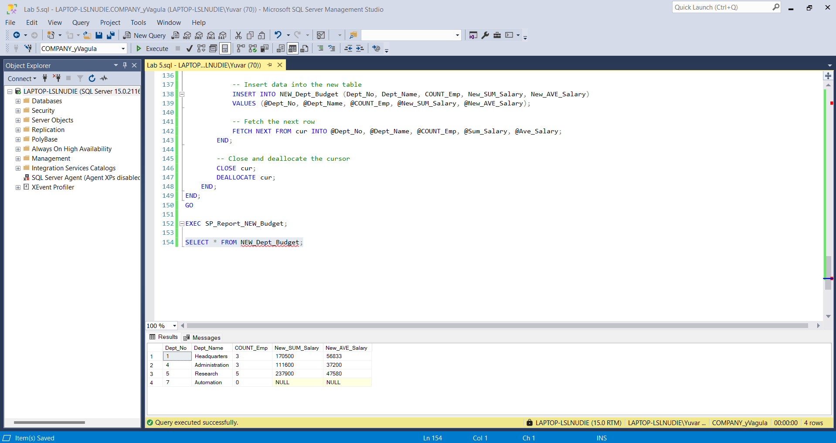

**PROOF OF PATH AND FILENAME**

